The project folder structure is generally shown as below. Occupancy ground truth generation is in folder “tools”. A typical data pipeline of generating occupancy ground truth summarized from SurroundOcc is shown in the next page. Nuscenes mini dataset is stored in folder “data/set/nuscenes”. Folder “config” contains config files for ground truth generation and model training. The trained model weight will be stored in “checkpoint”.

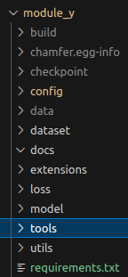

In the code, I adopted the original code and adapted a little bit to remove dependency on mmopenlab. Dataset is changed to nuscenes mini. And no training and validation is separated at this stage.

Lidar Point Cloud

Semantic Label Assignment

Voxelization

Poisson Surface Reconstruction

Re-merged static and dynamic scene

Dynamic Scene Insertion

Static Scene Stitching based on Ego Pose

Static/Dynamic Elements Separation

Point Cloud Processing

3D Object List

3D Semantic Segmentation

For neural network model, the data pipeline is shown as below. Training data of images and occupancy ground truth is processed by Dataset first to be resized, augmented, converted to tensor, etc. Then Dataloader iteratively sample batch data. Images tensor is going through backbone to extract feature, undergoing fusion for logic processing, and going to header to generate prediction. In this implementation, dataset related code are stored in folder “dataset”. All neural networks are dummy model stored in folder “model”. Loss is implemented in folder “loss”. Then the prediction tensor goes into Loss to compute loss value with sampled batch of ground truth. A very simple training example screenshot is give as below.

Images

Resize

Augment

To Tensor

Stack

Fusion

Backbone

Head

Ground truth

Loss

